PLANET | SYMBOL | PRINCIPLES | URGES | NEEDS | SIGN
MARS  Stone:  Red Garnet,  Red Coral | 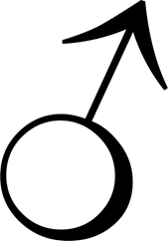 | - Desire  - Drive  - The will to Action  - Initiative | - To be self-assertive  - Can be aggressive or confrontational  - To act  - Sex | - Achieve desirers  - Physical excitement | Aries  And  Scorpio
VENUS  Stone:  Diamond |  | - Exchange energy with others  - Magnetism | - To love  - To attract  - To relate | - To feel close to others  - Luxury  - Beauty | Taurus  And  Libra
MERCURY  Stone:  Green Emerald,  Citroen | 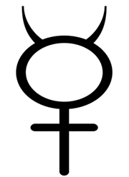 | - Communication  - Conscious mind | - To think  - To travel  - To link and understand  - To express through speech or skill | - To establish connections with others  - To learn | Gemini  And  Virgo
MOON  Stone:  Pearl,  Moonstone | 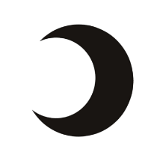 | - Reactive behaviour  - Subconscious predisposition  - Conditional response | - Instinctual  - To be safe and secure  - To survive  - Domesticated  - Emotional | - Emotional tranquillity  - Belonging | Cancer
SUN  Stone:  Red Ruby |  | - Vitality  - Individuality  - Creative energy  - Represents our essential values | - To be  - To exist  - To shine  - To feel alive  - To be successful | - To be recognised  - To express oneself | LEO
PLUTO | 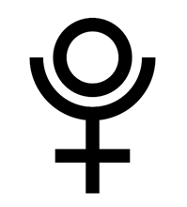 | - Transformation  - Transmutation  - Power and power struggles | - To be reborn  - To change  - To die  - To eliminate | - To refine the self  - Let go of the old through pain | Scorpio
JUPITER  Stone:  Yellow Sapphire | 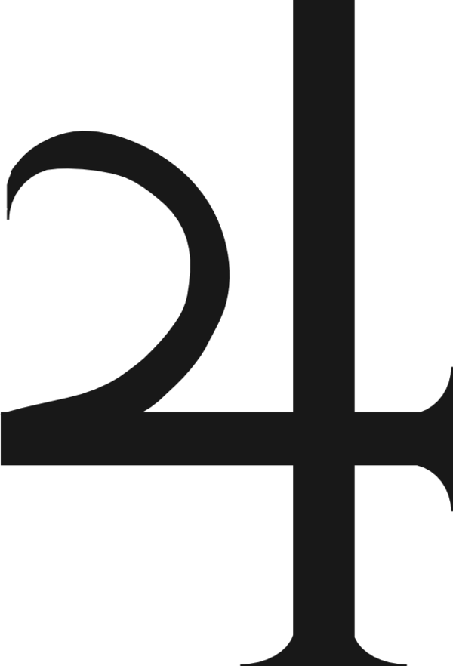 | - Expansion  - Grace | - To grow  - To have Abundance  - To be generous  - To travel | - Enthusiasm  - Faith  - Trust  - Confidence | Sagittarius  And  Pisces
SATURN  Stone:  Blue Sapphire | 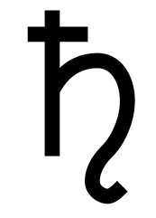 | - Contraction  - Effort | - To give structure to  - To organise or consolidate  - To work hard  - To be restricted | - Discipline  - Social approval  - To rely on own resources | Capricorn and Aquarius
URANUS | 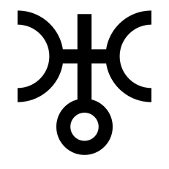 | - Individualistic  - Unique  - Rebel | - to be original  - to be different  - to be independent from tradition | - Change  - Expression without restraint | Aquarius
NEPTUNE | 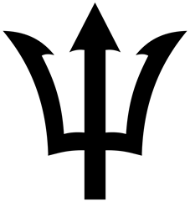 | - Transcendent  - Unification  - Mysticism | - To merge  - To be inspired  - To lose it  - To be free | - Unity with Source  - The experience of oneness | Pisces
NORTH NODE | 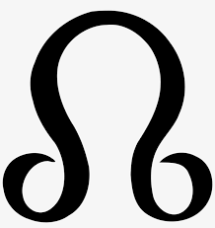 | Repeating theme  Makes good contacts with the sign it is in
SOUTH NODE |  | Intuitive knowledge of the house it is in  Past life experience
CHIRON | 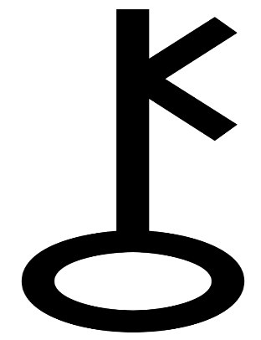 | Primal wound | Healing  Hurt
MC |  | Career
Ascending |  | Persona  How I come across to others  How I exchange energy with my environment |  | Planets by the Week  Monday – Moon  Tuesday – Mars  Wednesday – Mercury  Thursday – Jupiter  Friday – Venus  Saturday – Saturn  Sunday – Sun

