SIGN | SYMBOL | RULER | BODY PART | ABSTRACT
ARIES  Cardinal | 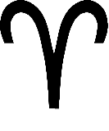 | Mars | Head  Eyes | The adventurous sprit  Action taking  Assertive in nature  Likes a challenge (head on)
TAURUS  Fixed | 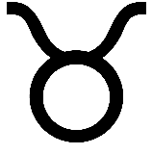 | Venus | Shoulders  Neck kidneys  Thyroid | Solid and reliable in nature  Body consciousness  Beaty  Money
GEMINI  Mutable | 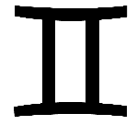 | Mercury | Lungs  Nervous system | Versatile  Duality driven  Mental in nature  Curious  Sometimes restless
CANCER  Cardinal | 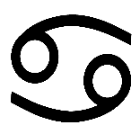 | Moon | Stomach  Breasts | Caring and nurturing  Seeks safe space and security  Emotional in nature
LEO  Fixed | 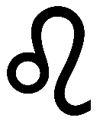 | Sun | Spine  Cardiovascular system | Expressive  Capable leaders but could be on the bossy side  Creative in nature  Capacity to inspire people
VIRGO  Mutable | 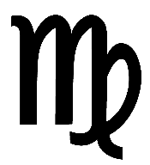 | Mercury | Small intestine  Gall bladder | Analytical  Versatile  Practical in nature  Problem solving
LIBRA  Cardinal | 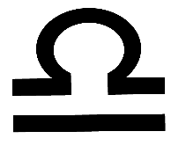 | Venus | Pelvis  Kidneys  Adrenal Glands | Balance and harmony  Relatable in nature  Beauty  Money
SCORPIO  Fixed | 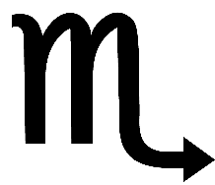 | Pluto / Mars | Sexual organs  Colon | Capacity to apply intense focus but can be obsessive  Transformative in nature  May apply manipulation
SAGITTARIUS  Mutable | 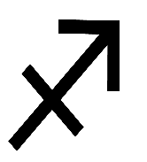 | Jupiter | Liver  Legs | Seeks freedom  Generous in nature  Broadminded  Enthusiastic  Sometimes restless
CAPRICORN  Cardinal | 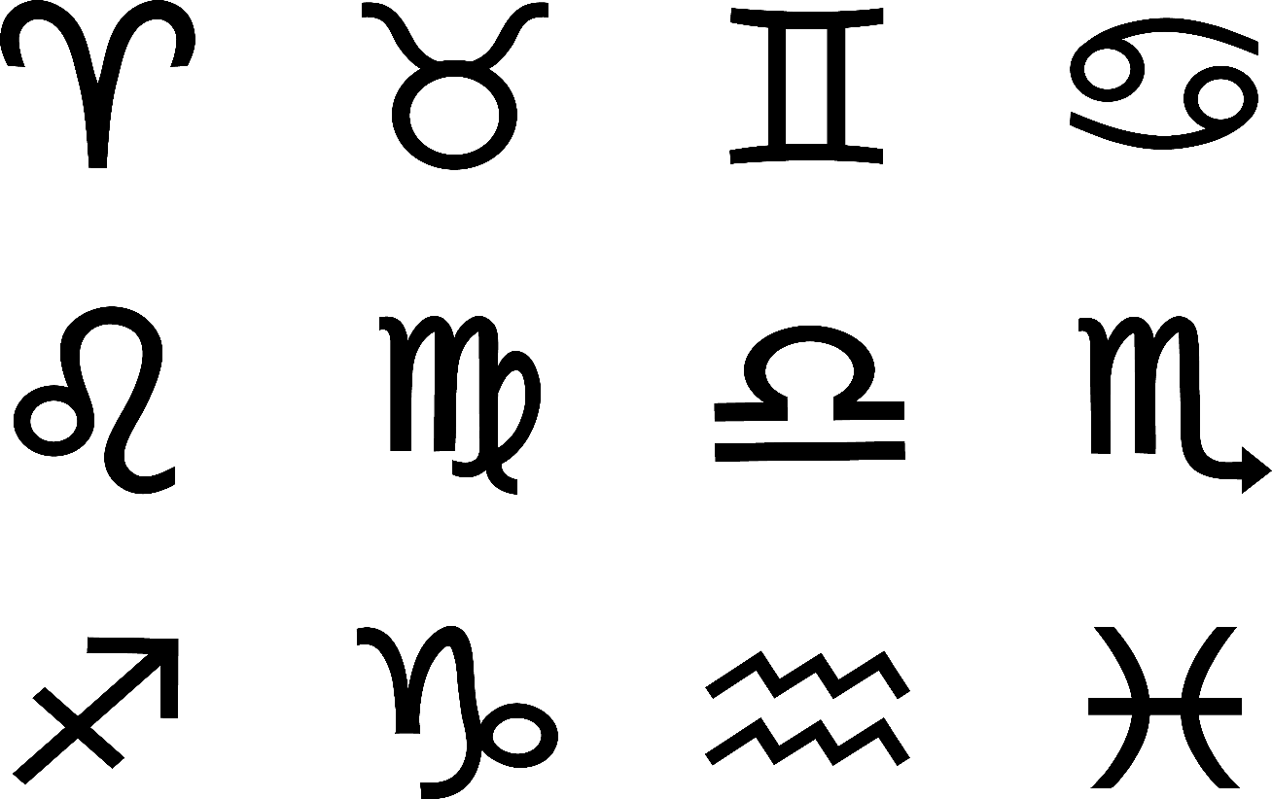 | Saturn | Knees  Joints | Have direction  Structured in nature  Capable managers but can be controlling
AQUARIUS  Fixed | 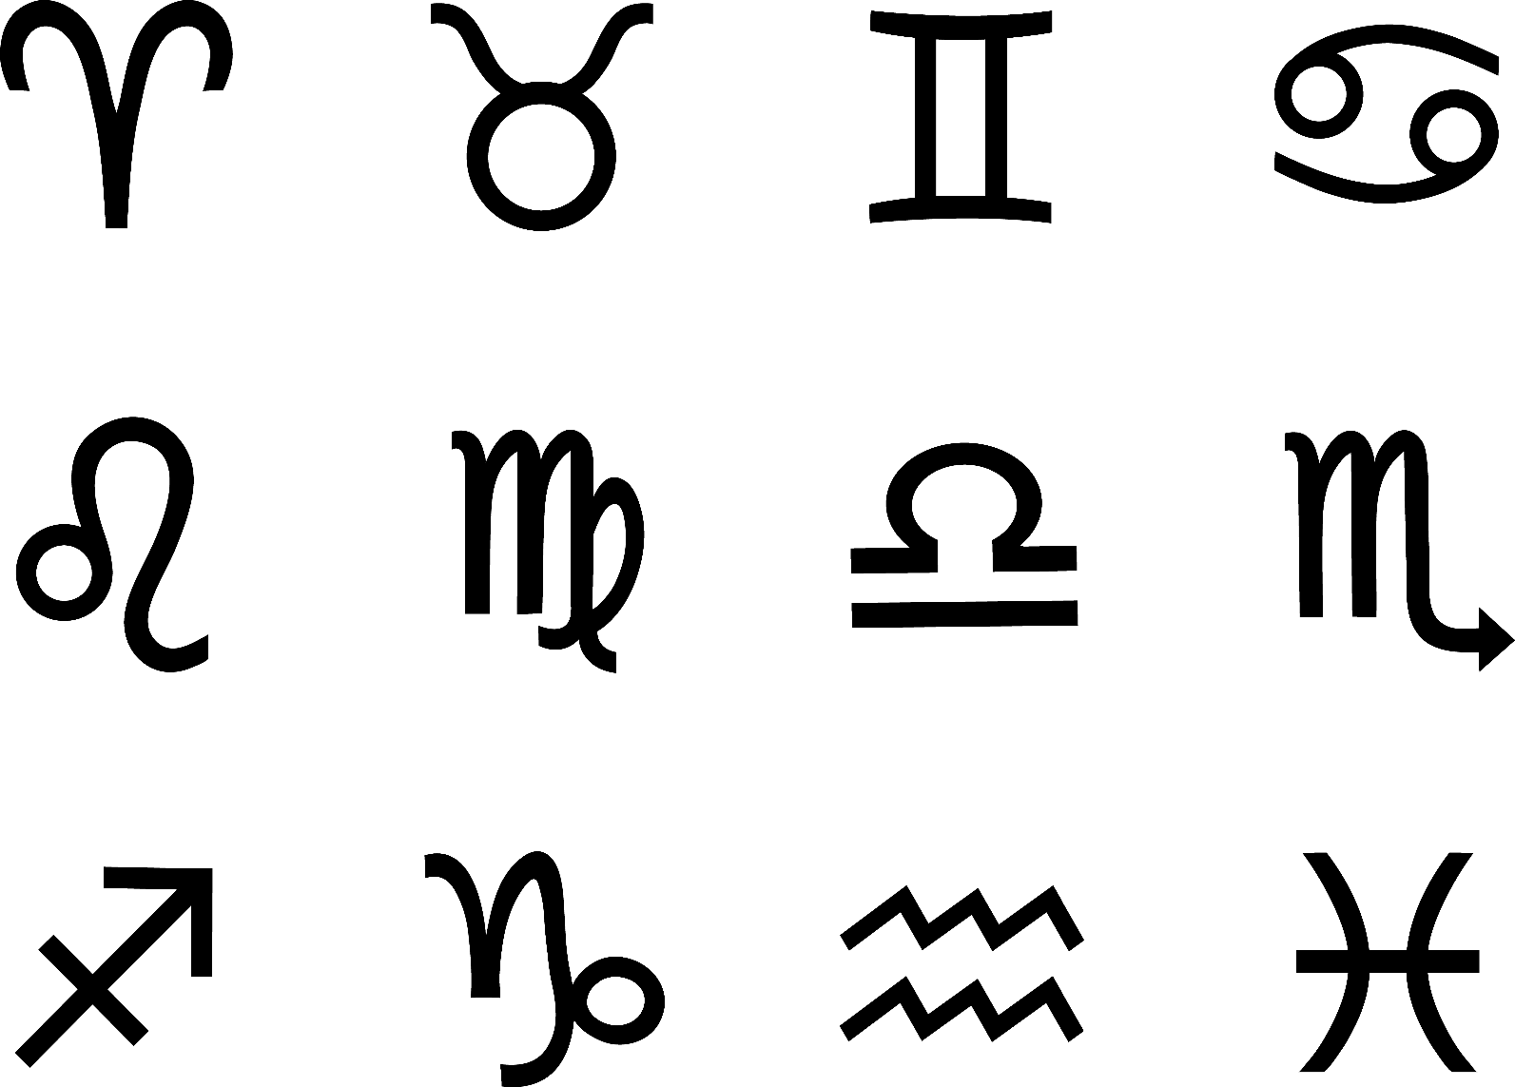 | Uranus / Saturn | Ankles  Autonomic nervous system | Individualistic  Detached in nature  Different or off the beaten track  Rebellious at times  Original
PISCES  Mutable | 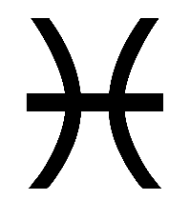 | Neptune / Jupiter | Fleet  Fluids  Lymph | Service orientated  Visionary in nature  Wow effect  Transcendental  Dreamy

